Title: Chronic disturbance modulates symbiont (Symbiodiniaceae) beta diversity on a coral reef

Authors: Danielle C. Claar^{1*}, Kristina L. Tietjen¹, Kieran D. Cox^{1,2}, Ruth D. Gates³, Julia K. Baum^{1,3}

1 Department of Biology, University of Victoria, Victoria, British Columbia, V8W 2Y2, Canada.
2 Hakai Institute, Calvert Island, British Columbia, Canada
3 Hawaii Institute of Marine Biology, Kaneohe, HI 96744, USA

Supplementary Materials

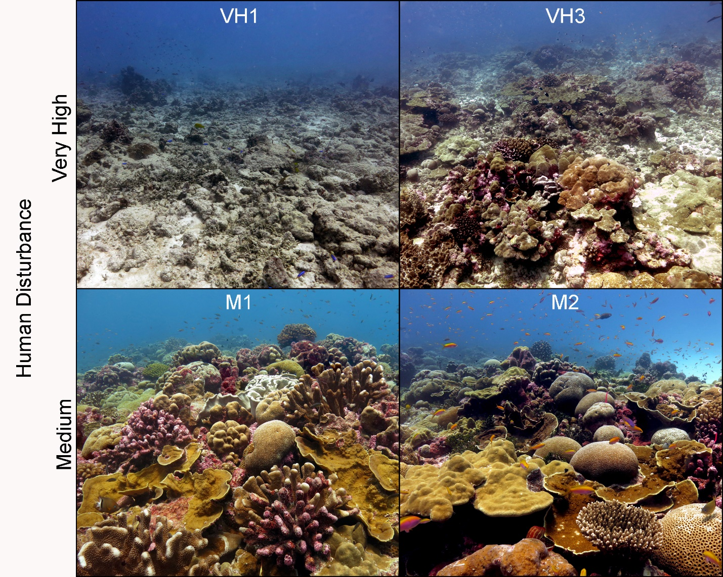
Supplementary Figure S1. Images of sites exposed to different levels of relative local human disturbance (very high, medium) on Kiritimati that were included in this study. Note: Sites are part of a larger ecological monitoring program that includes sites with very high, high, medium, low, and very low levels of disturbance.

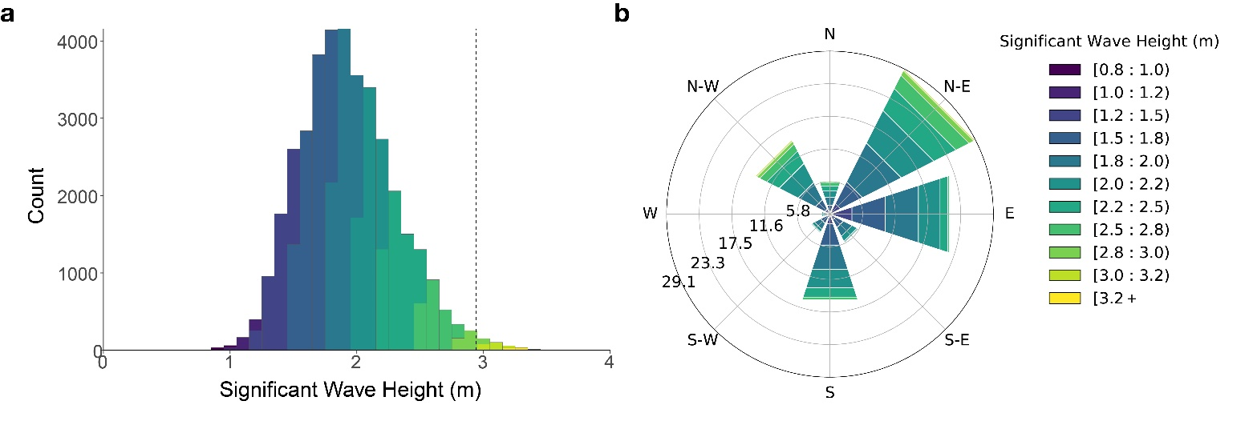
Supplementary Figure S2. Wave climate on Kiritimati (2005-2017) extracted from NOAA’s Wavewatch III hindcast product. Plots are based on 3-hourly wave models. a Histogram of significant wave height. Colors indicate significant wave height, and dashed line on panel a indicates maximum wave height on Kiritimati in January 2015 (2.94 m). b Polar rose showing average wave conditions. Each bin represents 45° increments. Colors indicate significant wave height, angle of each bin indicates direction of incoming waves, and distance from center represents the probability (percentage) of waves coming from each direction.

Supplementary Figure S3. Bar plots of Symbiodiniaceae taxa, colored by genus in the different reef compartments and coral species: a sediment, b water, c Montipora aequituberculata, d Pocillopora grandis, e Porites lobata.

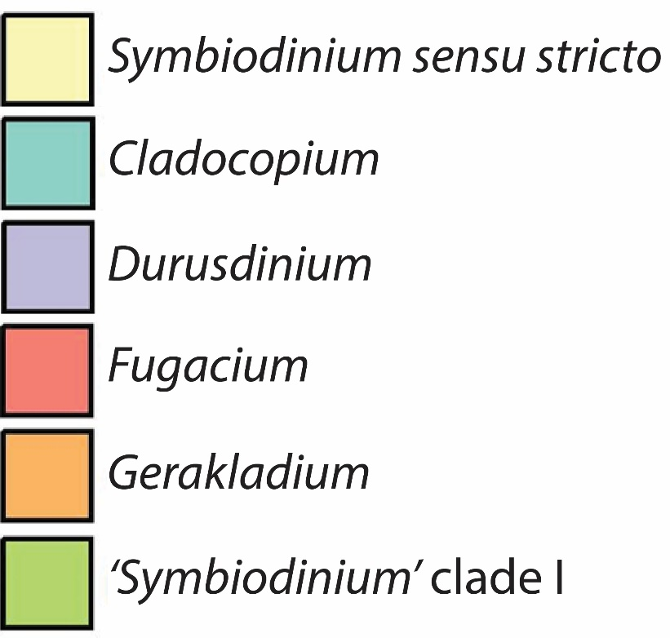
Supplementary Figure S3. a Sediment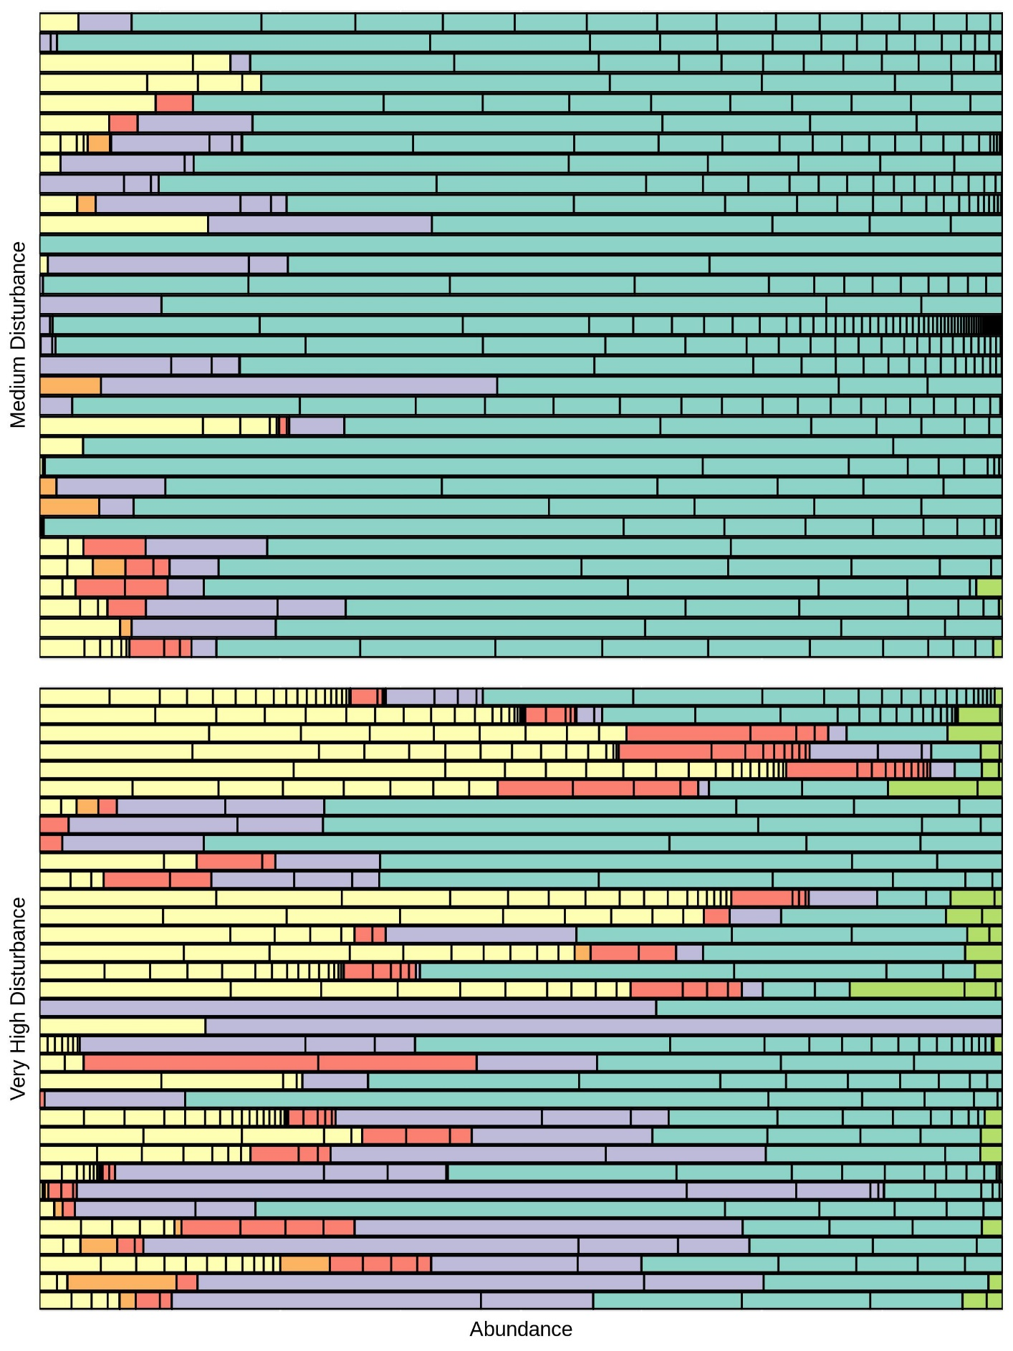
Supplementary Figure S3. b Water
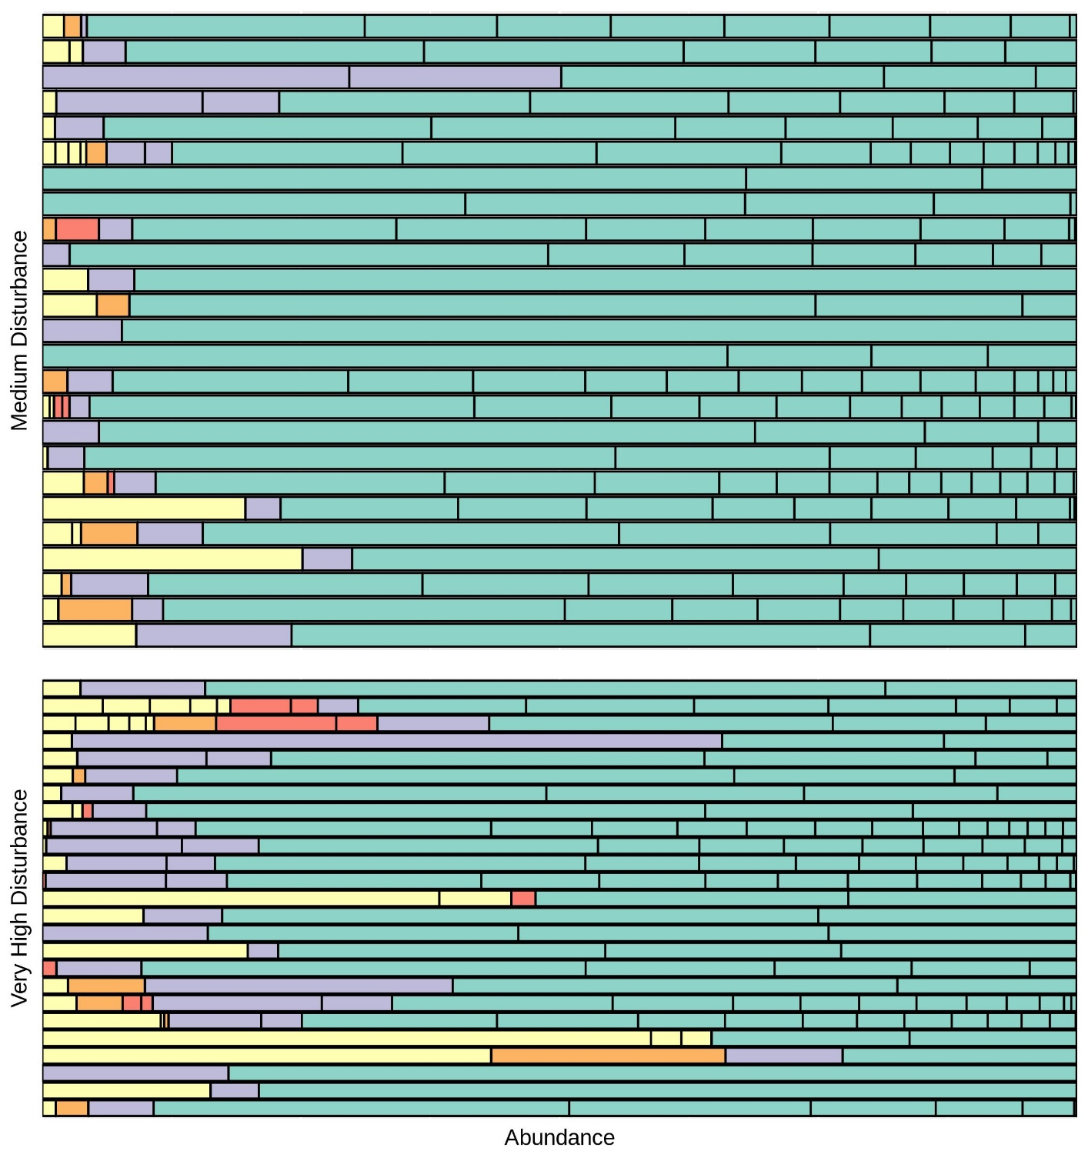

Supplementary Figure S3. c Montipora aequituberculata
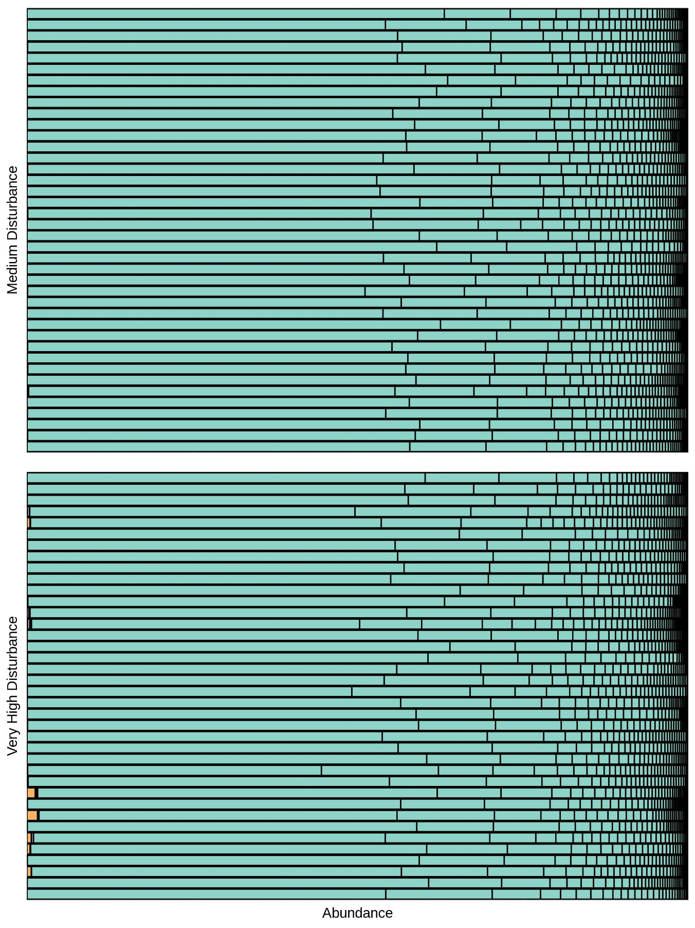

Supplementary Figure S3. d Pocillopora grandis
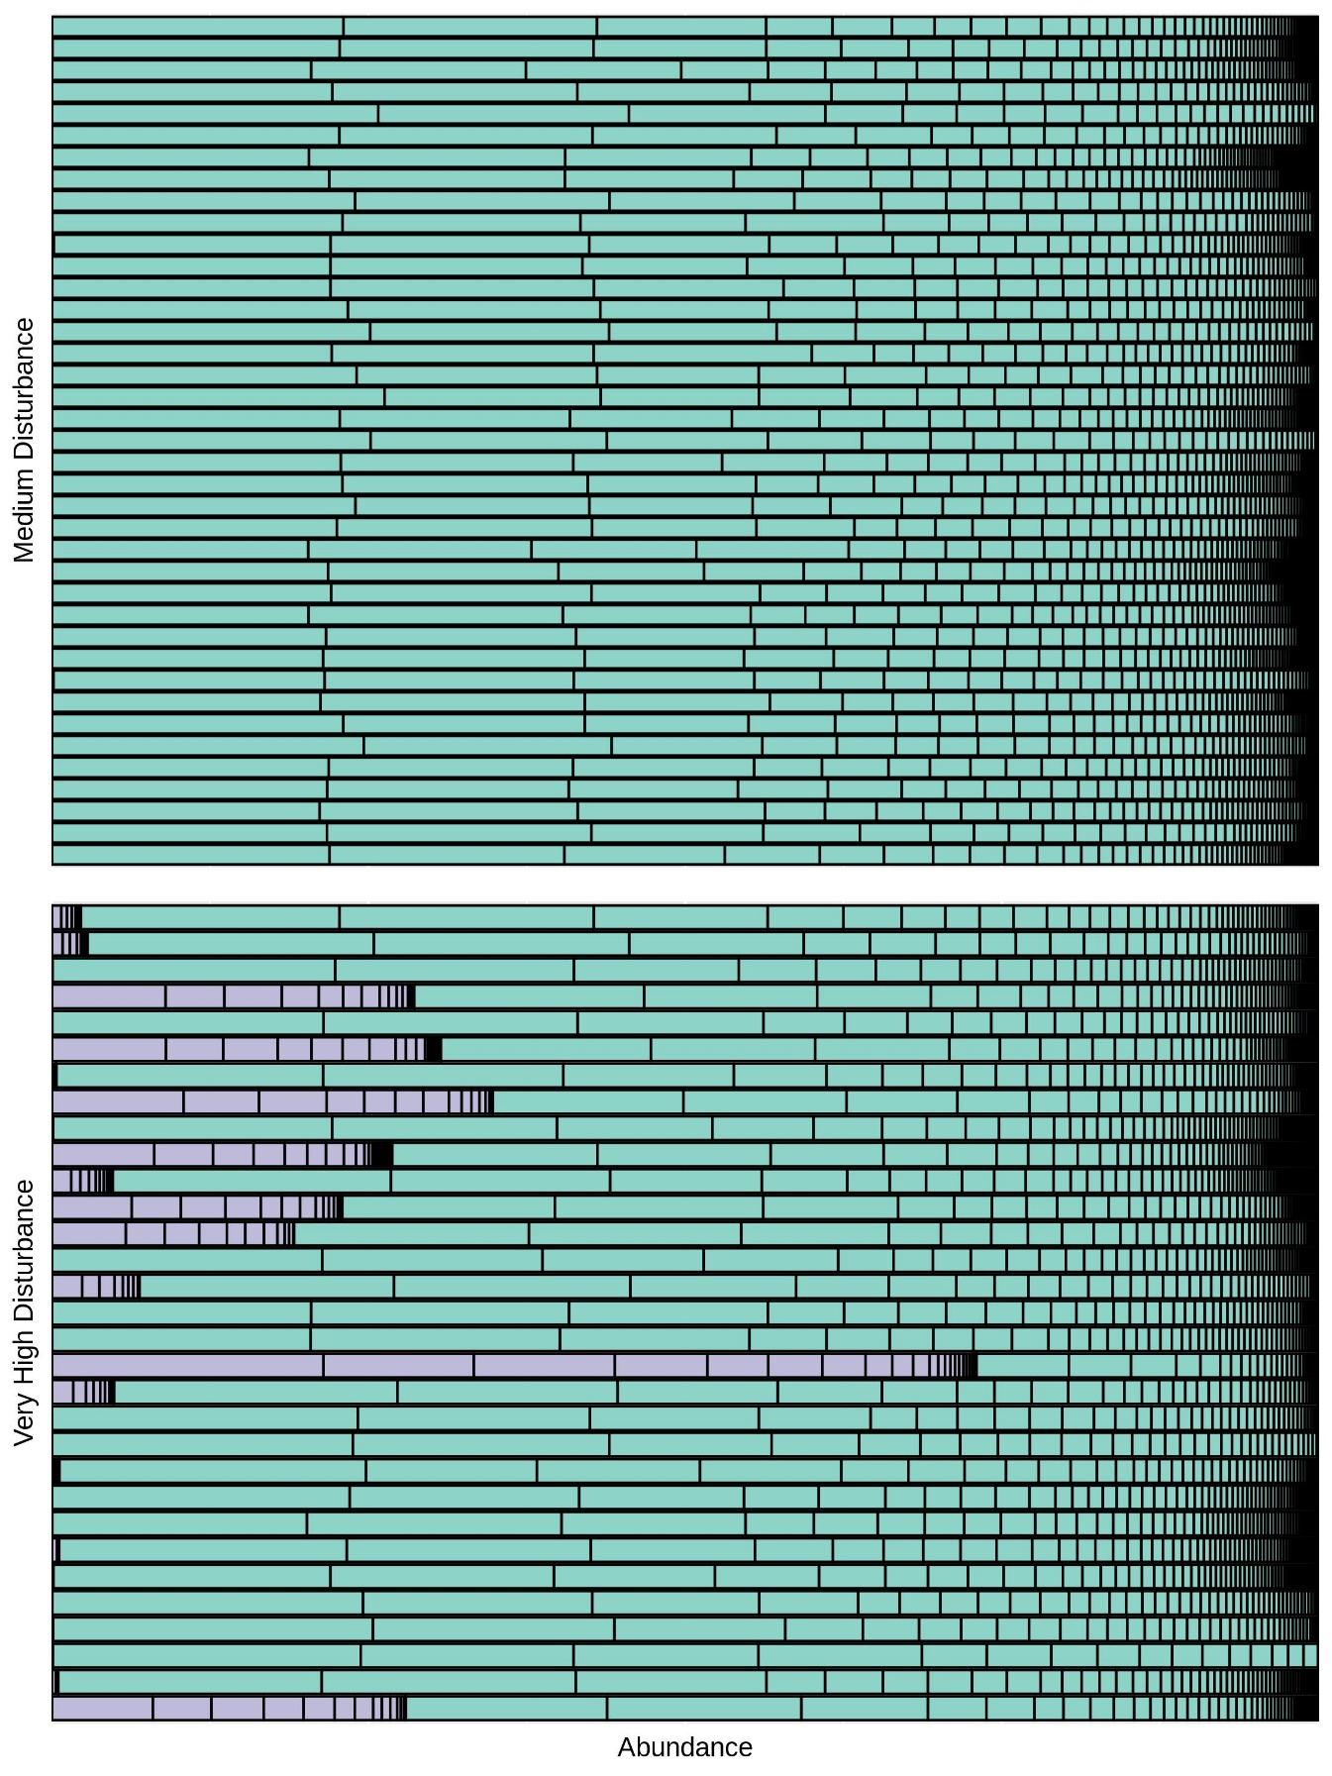

Supplementary Figure S3. e Porites lobata
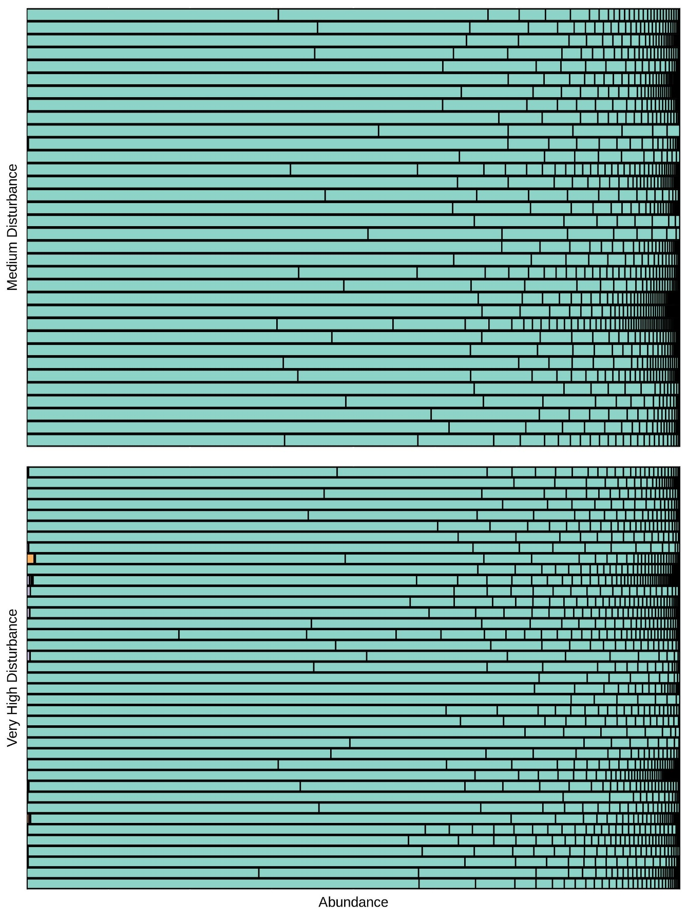

Supplementary Figure S4. Interpolation-Extrapolation plots for coral a by disturbance level; b by site; c by field season
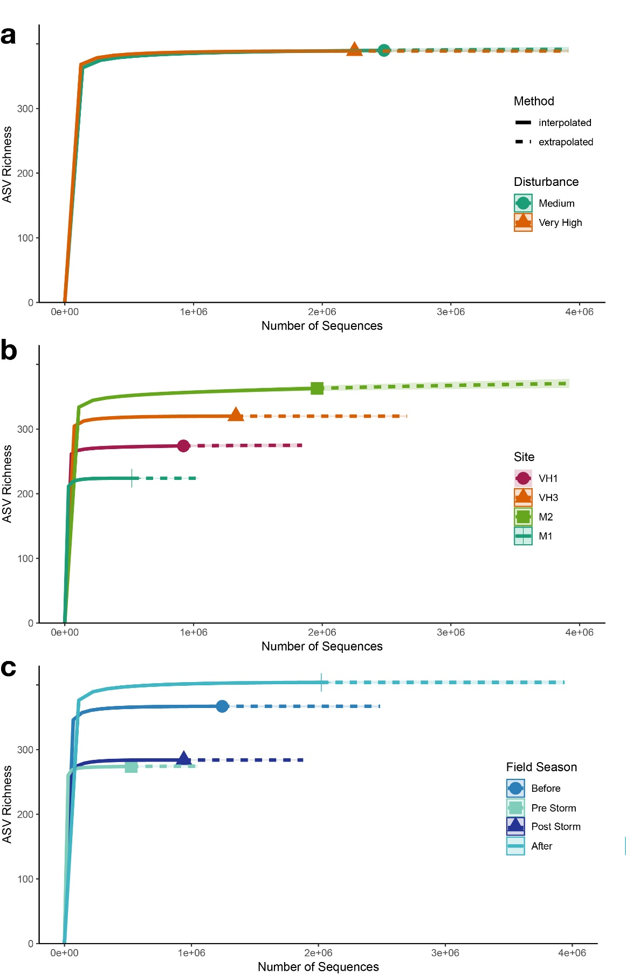
Supplementary Figure S5. Interpolation-Extrapolation plots for sediment a by disturbance level; b by site; c by field season
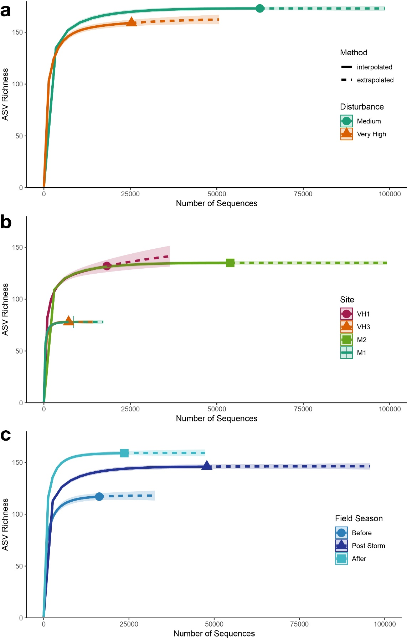
Supplementary Figure S6. Interpolation-Extrapolation plots for water a by disturbance level; b by site; c by field season
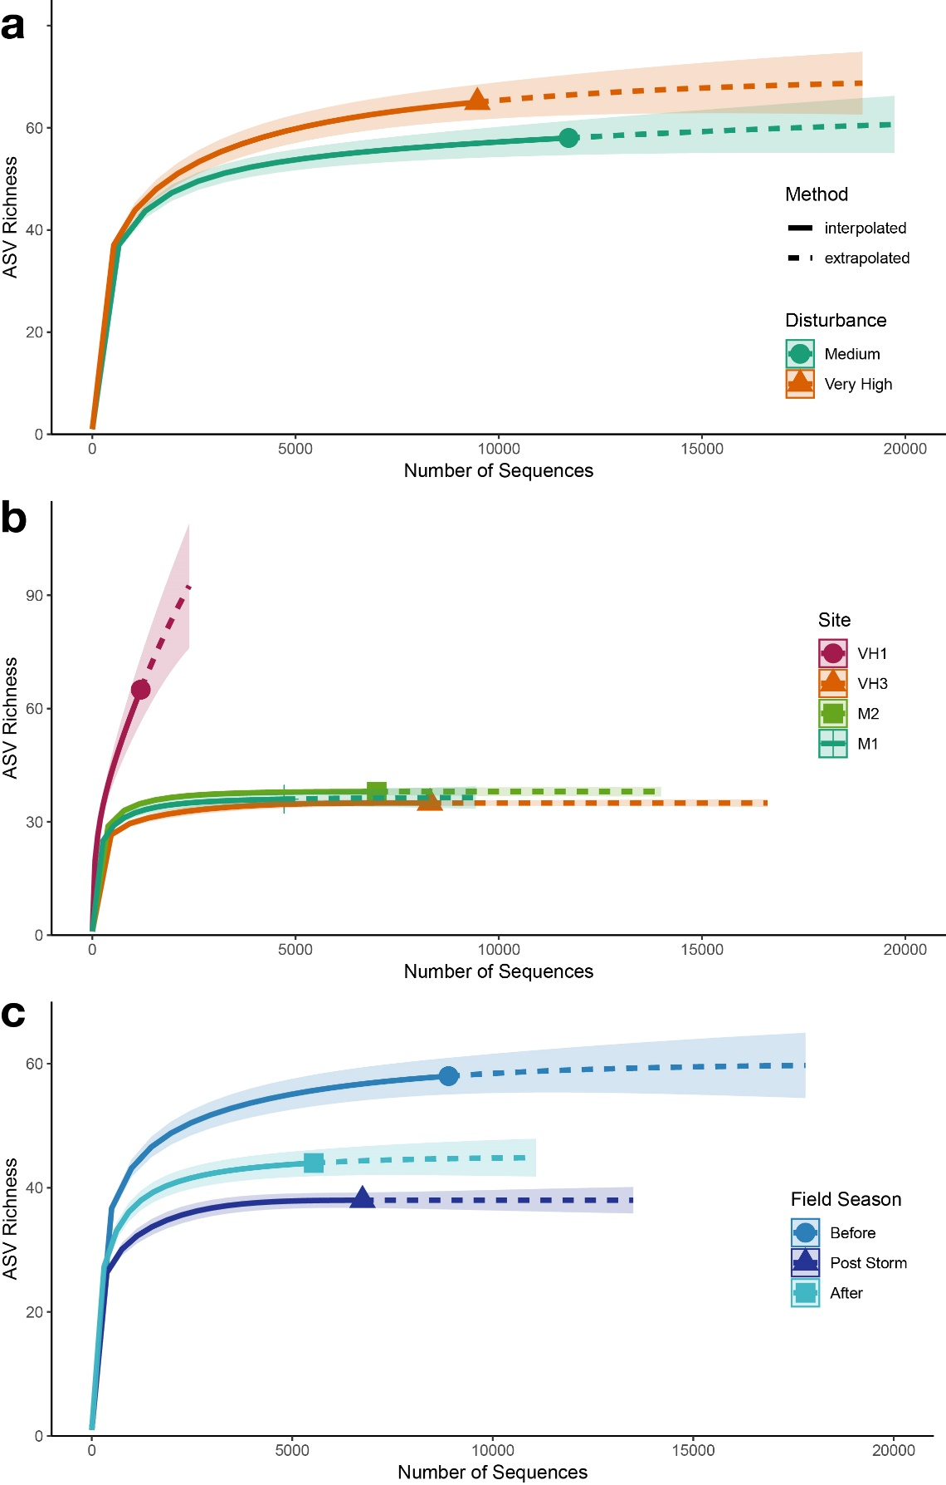
Supplementary Table S1. Sample size of water, sediment, and corals by site and time point (August 2014, Before; January 2015, Pre-Storm; January 2015, Post-Storm; May 2015, After). Number of samples reported in “All Coral” is the sum of all samples in Pocillopora grandis, Montipora aequituberculata, and Porites lobata.

Site Name | Site  ID | Field Season | Water | Sediment | All Coral | Pocillopora grandis | Montipora aequituberculata | Porites lobata | TOTAL
M1 | 8 | Before | 4 | 6 | 6 | 2 | 3 | 1 | 16
 |  | Pre-Storm | - | - | - | - | - | - | 0
 |  | Post-Storm | 4 | 5 | 6 | 2 | 3 | 1 | 10
 |  | After | 2 | 5 | 12 | 3 | 6 | 3 | 19
 |  | Total this Site | 10 | 16 | 24 | 7 | 12 | 5
VH1 | 27 | Before | 4 | 5 | 13 | 3 | 5 | 5 | 18
 |  | Pre-Storm | - | - | - | - | - | - | 0
 |  | Post-Storm | 4 | 6 | 14 | 4 | 5 | 5 | 19
 |  | After | 4 | 6 | 16 | 4 | 7 | 5 | 24
 |  | Total this Site | 12 | 17 | 43 | 11 | 17 | 15
VH3 | 30 | Before | 5 | 6 | 18 | 5 | 6 | 7 | 29
 |  | Pre-Storm | - | - | - | - | - | - | 0
 |  | Post-Storm | 4 | 6 | 18 | 5 | 6 | 7 | 26
 |  | After | 4 | 5 | 29 | 10 | 9 | 10 | 37
 |  | Total this Site | 13 | 17 | 65 | 20 | 21 | 24
M2 | 35 | Before | 7 | 6 | 22 | 7 | 7 | 8 | 34
 |  | Pre-Storm | - | - | 16 | 6 | 6 | 4 | 16
 |  | Post-Storm | 4 | 5 | 21 | 8 | 6 | 7 | 30
 |  | After | 4 | 6 | 30 | 11 | 9 | 10 | 40
 |  | Total this Site | 15 | 17 | 89 | 32 | 28 | 29
TOTAL |  |  | 50 | 67 | 221 | 70 | 73 | 78 | 338

Supplementary Table 2. Calculation of human disturbance categories on Kiritimati. Intersect_Pop_2km includes the number of people residing within 2 km of each site. Calculated based on Kiribati Population Census report. Fishing Buffer is a kernel density function of fishing intensity with ten discrete levels (from Watson et al. 2016). Intersect_Pop+Fishing is the sum of the previous two columns. Based on these calculations, sites are categorized into five distinct human disturbance categories. Site Name is included for cross-comparisons with other related Kiritimati publications. Note: Sites are part of a larger ecological monitoring program that includes sites with very high, high, medium, low, and very low levels of disturbance.

Site Name | Intersect_Pop_2km | Fishing_Buffer | Intersect_Pop+Fishing | Disturbance Category
VH1 | 4042 | 3234 | 7276 | Very High
VH3 | 3065 | 2021 | 5086 | Very High
M1 | 0 | 1213 | 1213 | Medium
M2 | 0 | 1213 | 1213 | Medium

Supplementary Table 3. Environmental parameters on Kiritimati. In situ values are mean ± s.d. for field seasons 2014 and 2015b. Chronic local human disturbance impacts both visibility and coral cover. Visibility was assessed by the same scientific diver pair during each dive. Coral cover was assessed using benthic photographs analyzed in CoralNet ¹. Temperature, salinity, pH, and DO saturation were collected using a YSI ProPlus handheld sensor that was calibrated daily. Wave intensity and net primary production (NPP) were extracted from satellite data ². Wave energy and NPP Mean represent the general means of each value, and NPP Max represents the mean annual maximum.

Disturbance | Visibility (m) | Coral Cover (%)
Medium | 16 ± 5 | 41.4 ± 9
Very high | 13 ± 2 | 17.2 ± 22

Disturbance | Temperature (°C) | Salinity (ppt) | pH | DO Saturation (%) | Wave Energy  (kW m⁻¹)
Medium | 29.1 ± 0.05 | 35.1 ± 0.02 | 8.02 ± 0.04 | 98 ± 7 | 25 ± 0
Very high | 29.1 ± 0.16 | 35.7 ± 0.84 | 8.05 ± 0.03 | 91 ± 3 | 14 ± 13

Disturbance | NPP Mean  (mg C m⁻² day⁻¹) | NPP Max  (mg C m⁻² day⁻¹)
Medium | 965 ± 0 | 1078 ± 0
Very high | 895 ± 4 | 1104 ± 8

Supplementary Table 4. Volumes of water filtered for each sample.
Sample ID | Field Season | Site Name | Volume (L) | Sample Date
KI14WSYM004 | 2014 | M1 | 6.0 | 23-Aug-2014
KI14WSYM003 | 2014 | M1 | 8.0 | 23-Aug-2014
KI14WSYM031 | 2014 | M1 | 8.0 | 02-Sep-2014
KI14WSYM021 | 2014 | M1 | 7.2 | 29-Aug-2014
KI14WSYM011 | 2014 | VH1 | 6.5 | 26-Aug-2014
KI14WSYM012 | 2014 | VH1 | 6.3 | 26-Aug-2014
KI14WSYM013 | 2014 | VH1 | 7.1 | 27-Aug-2014
KI14WSYM014 | 2014 | VH1 | 6.1 | 27-Aug-2014
KI14WSYM015 | 2014 | VH3 | 5.5 | 27-Aug-2014
KI14WSYM016 | 2014 | VH3 | 6.5 | 27-Aug-2014
KI14WSYM032 | 2014 | VH3 | 7.6 | 03-Sep-2014
KI14WSYM008 | 2014 | VH3 | 7.7 | 25-Aug-2014
KI14WSYM017 | 2014 | VH3 | 5.7 | 27-Aug-2014
KI14WSYM001 | 2014 | M2 | 7.0 | 21-Aug-2014
KI14WSYM005 | 2014 | M2 | 6.5 | 24-Aug-2014
KI14WSYM028 | 2014 | M2 | 8.6 | 02-Sep-2014
KI14WSYM029 | 2014 | M2 | 8.4 | 02-Sep-2014
KI14WSYM030 | 2014 | M2 | 4.7 | 02-Sep-2014
KI14WSYM006 | 2014 | M2 | 6.2 | 24-Aug-2014
KI14WSYM007 | 2014 | M2 | 7.4 | 24-Aug-2014
KI15aWSYM005 | 2015a | M1 | 8.0 | 1-Feb-2015
KI15aWSYM006 | 2015a | M1 | 8.0 | 1-Feb-2015
KI15aWSYM007 | 2015a | M1 | 9.0 | 1-Feb-2015
KI15aWSYM008 | 2015a | M1 | 10.2 | 1-Feb-2015
KI15aWSYM013 | 2015a | VH1 | 9.0 | 2-Feb-2015
KI15aWSYM014 | 2015a | VH1 | 8.4 | 2-Feb-2015
KI15aWSYM015 | 2015a | VH1 | 8.2 | 2-Feb-2015
KI15aWSYM016 | 2015a | VH1 | 8.8 | 2-Feb-2015
KI15aWSYM017 | 2015a | VH3 | 6.0 | 2-Feb-2015
KI15aWSYM018 | 2015a | VH3 | 7.0 | 2-Feb-2015
KI15aWSYM019 | 2015a | VH3 | 7.6 | 2-Feb-2015
KI15aWSYM020 | 2015a | VH3 | 7.8 | 2-Feb-2015
KI15aWSYM009 | 2015a | M2 | 8.4 | 1-Feb-2015
KI15aWSYM010 | 2015a | M2 | 8.0 | 1-Feb-2015
KI15aWSYM011 | 2015a | M2 | 9.0 | 1-Feb-2015
KI15aWSYM012 | 2015a | M2 | 7.0 | 1-Feb-2015
KI15bWSYM023 | 2015b | M1 | 6.5 | 4-May-2015
KI15bWSYM024 | 2015b | M1 | 7.5 | 4-May-2015
KI15bWSYM017 | 2015b | VH1 | 3.7 | 3-May-2015
KI15bWSYM018 | 2015b | VH1 | 6.2 | 3-May-2015
KI15bWSYM019 | 2015b | VH1 | 7.1 | 3-May-2015
KI15bWSYM020 | 2015b | VH1 | 4.8 | 3-May-2015
KI15bWSYM005 | 2015b | VH3 | 3.9 | 1-May-2015
KI15bWSYM006 | 2015b | VH3 | 4.4 | 1-May-2015
KI15bWSYM007 | 2015b | VH3 | 4.8 | 1-May-2015
KI15bWSYM008 | 2015b | VH3 | 10.5 | 1-May-2015
KI15bWSYM001 | 2015b | M2 | 3.0 | 30-Apr-2015
KI15bWSYM002 | 2015b | M2 | 6.7 | 30-Apr-2015
KI15bWSYM003 | 2015b | M2 | 8.1 | 30-Apr-2015
KI15bWSYM004 | 2015b | M2 | 6.2 | 30-Apr-2015

Supplementary Table 5. Volume of sediment filtered for each sample.
Sample ID | Field Season | Site Name | Sediment (mL) | Sample Date
KI14SSYM003 | 2014 | M1 | 7 | 23-Aug-2014
KI14SSYM004 | 2014 | M1 | 6.2 | 23-Aug-2014
KI14SSYM005 | 2014 | M1 | 3 | 23-Aug-2014
KI14SSYM006 | 2014 | M1 | 3.5 | 23-Aug-2014
KI14SSYM007 | 2014 | M1 | 3 | 23-Aug-2014
KI14SSYM008 | 2014 | M1 | 2 | 23-Aug-2014
KI14SSYM058 | 2014 | VH1 | 3 | 07-Sep-2014
KI14SSYM059 | 2014 | VH1 | 3 | 07-Sep-2014
KI14SSYM060 | 2014 | VH1 | 3.5 | 07-Sep-2014
KI14SSYM061 | 2014 | VH1 | 3 | 07-Sep-2014
KI14SSYM063 | 2014 | VH1 | 3 | 07-Sep-2014
KI14SSYM015 | 2014 | VH3 | 3.8 | 25-Aug-2014
KI14SSYM016 | 2014 | VH3 | 3 | 25-Aug-2014
KI14SSYM017 | 2014 | VH3 | 3 | 25-Aug-2014
KI14SSYM018 | 2014 | VH3 | 3 | 25-Aug-2014
KI14SSYM019 | 2014 | VH3 | 3 | 25-Aug-2014
KI14SSYM020 | 2014 | VH3 | 3 | 25-Aug-2014
KI14SSYM010 | 2014 | M2 | 3 | 24-Aug-2014
KI14SSYM011 | 2014 | M2 | 3 | 24-Aug -2014
KI14SSYM012 | 2014 | M2 | 3 | 24-Aug -2014
KI14SSYM013 | 2014 | M2 | 3 | 24-Aug -2014
KI14SSYM014 | 2014 | M2 | 3 | 24-Aug-2014
KI14SSYM050 | 2014 | M2 | 3 | 02-Sep-2014
KI15aSSYM025 | 2015a | M1 | 3 | 2-Feb-2015
KI15aSSYM026 | 2015a | M1 | 3 | 2-Feb-2015
KI15aSSYM027 | 2015a | M1 | 3 | 2-Feb-2015
KI15aSSYM029 | 2015a | M1 | 3 | 2-Feb-2015
KI15aSSYM030 | 2015a | M1 | 3 | 2-Feb-2015
KI15aSSYM019 | 2015a | VH1 | 3 | 2-Feb-2015
KI15aSSYM020 | 2015a | VH1 | 3 | 2-Feb-2015
KI15aSSYM021 | 2015a | VH1 | 3 | 2-Feb-2015
KI15aSSYM022 | 2015a | VH1 | 3 | 2-Feb-2015
KI15aSSYM023 | 2015a | VH1 | 3 | 2-Feb-2015
KI15aSSYM024 | 2015a | VH1 | 3 | 2-Feb-2015
KI15aSSYM013 | 2015a | VH3 | 3 | 2-Feb-2015
KI15aSSYM014 | 2015a | VH3 | 3 | 2-Feb-2015
KI15aSSYM015 | 2015a | VH3 | 3 | 2-Feb-2015
KI15aSSYM016 | 2015a | VH3 | 3 | 2-Feb-2015
KI15aSSYM017 | 2015a | VH3 | 3 | 2-Feb-2015
KI15aSSYM018 | 2015a | VH3 | 3 | 2-Feb-2015
KI15aSSYM009 | 2015a | M2 | 3 | 1-Feb-2015
KI15aSSYM010 | 2015a | M2 | 3 | 1-Feb-2015
KI15aSSYM011 | 2015a | M2 | 3 | 1-Feb-2015
KI15aSSYM012 | 2015a | M2 | 3 | 1-Feb-2015
KI15bSSYM019 | 2015b | M1 | 3 | 4-May-2015
KI15bSSYM024 | 2015b | M1 | 3 | 4-May-2015
KI15bSSYM021 | 2015b | M1 | 3 | 4-May-2015
KI15bSSYM023 | 2015b | M1 | 3 | 4-May-2015
KI15bSSYM022 | 2015b | M1 | 3 | 4-May-2015
KI15bSSYM014 | 2015b | VH1 | 3 | 3-May-2015
KI15bSSYM013 | 2015b | VH1 | 3 | 3-May-2015
KI15bSSYM017 | 2015b | VH1 | 3 | 3-May-2015
KI15bSSYM016 | 2015b | VH1 | 3 | 3-May-2015
KI15bSSYM018 | 2015b | VH1 | 3 | 3-May-2015
KI15bSSYM015 | 2015b | VH1 | 3 | 3-May-2015
KI15bSSYM007 | 2015b | VH3 | 3 | 1-May-2015
KI15bSSYM008 | 2015b | VH3 | 3 | 1-May-2015
KI15bSSYM009 | 2015b | VH3 | 3 | 1-May-2015
KI15bSSYM010 | 2015b | VH3 | 3 | 1-May-2015
KI15bSSYM012 | 2015b | VH3 | 3 | 1-May-2015
KI15bSSYM004 | 2015b | M2 | 3 | 30-Apr-2015
KI15bSSYM001 | 2015b | M2 | 3 | 30-Apr-2015
KI15bSSYM006 | 2015b | M2 | 3 | 30-Apr-2015
KI15bSSYM002 | 2015b | M2 | 3 | 30-Apr-2015
KI15bSSYM005 | 2015b | M2 | 3 | 30-Apr-2015
KI15bSSYM003 | 2015b | M2 | 3 | 30-Apr-2015

Supplementary Table 6. Sample sizes from bootstrapped sensitivity analysis. This table includes only reef habitat compartments that demonstrated significant results for both PERMANOVA (adonis) and PERMDISP (betadisper). Columns “Medium”, “Very High”, “2014”, “2015a”, and “2015b” show original sample size included in the main analysis. Columns “Subsampled to” show the level that samples were subsampled to within each factor level.

 | Medium | Very High | Subsampled to | 2014 | 2015a | 2015b | Subsampled to
Water | 25 | 25 | NA
Sediment | 33 | 34 | 33 | 23 | 22 | 22 | 22
P. eydouxi | 39 | 31 | 31
All samples | 171 | 167 | 167

Supplementary References
1. Beijbom, O. et al. Towards automated annotation of benthic survey images: Variability of human experts and operational modes of automation. PLoS ONE 10, e0130312 (2015).
2. Yeager, L. A., Marchand, P., Gill, D. A., Baum, J. K. & McPherson, J. M. Marine Socio-Environmental Covariates: queryable global layers of environmental and anthropogenic variables for marine ecosystem studies. Ecology 98, 1976 (2017).

