Supplementary material for: Effects of climate-change driven gradual and acute temperature changes on shark and ray species

Geoffrey J. Osgood¹, Easton R. White^{2,3}, & Julia K. Baum^{1*}

¹ Department of Biology, University of Victoria, Victoria, British Columbia, Canada
² Department of Biological Sciences, University of New Hampshire, Durham, New Hampshire, USA
³ Gund Institute for Environment, University of Vermont, Burlington, Vermont

*Corresponding Author: baum@uvic.ca

Online supplemental material:
- Model results for each species
- Percent change for each species
- Additional figures of raw count data
- Model assumption figures

Table S1. The z-values (and p-values) from Wald Z-tests for the SST and ONI variables in the models for each species. The ONI effects for G. cuvier and A. narinari represent the significance of the linear, quadratic, and cubic terms, respectively, when appropriate.

Species | SST effect | ONI effect
Galeocerdo cuvier | 5.9 (<0.001) | -6.2 (<0.001)  -2.7 (0.007)  4.7 (<0.001)
Sphyrna lewini | -8.1 (<0.001) | -14.5 (<0.001)
S. lewini schooling probability | -4.3 (<0.001) | -7.1 (<0.001)
Carcharhinus limbatus | 0.020 (0.69) | 0.12 (0.022)
Triaenodon obesus | -7.4 (<0.001) | -2.2 (0.024)
Mobula spp. | -4.2 (<0.001) | -1.0 (0.30)
Aetobatus narinari | 2.7 (0.0059) | 0.992 (0.32)  6.2 (<0.001)
Taeniura meyeni | -5.6 (<0.001) | -13.7 (<0.001)

Table S2. The predicted mean abundance or probability (schooling, Carcharhinus limbatus, Galeocerdo cuvier, Mobula spp.) at particular sea surface temperatures and levels of ONI when each of the other variables in the model was held at its average or baseline (0 for current code). Julian date was set as the mean Julian date in the year with the highest total count of that species.
Species | Mean SST | 1°C (1 SD) above mean SST | 25°C | 30°C | Weak El Niño | Moderate El Niño | Strong El Niño | Weak  La Niña | Moderate La Niña | Strong La Niña
Galeocerdo cuvier | 0.085 | 0.090 | 0.072 | 0.097 | 0.065 | 0.050 | 0.043 | 0.10 | 0.10 | 0.080
Sphyrna lewini | 7.9 | 7.1 | 10.5 | 6.3 | 7.0 | 6.2 | 5.5 | 8.9 | 10.0 | 11.3
S. lewini schooling probability | 0.037 | 0.033 | 0.051 | 0.029 | 0.033 | 0.029 | 0.025 | 0.043 | 0.049 | 0.056
Carcharhinus limbatus | 0.013 | 0.013 | 0.012 | 0.014 | 0.014 | 0.015 | 0.016 | 0.012 | 0.012 | 0.011
Triaenodon obesus | 26.4 | 25.3 | 29.6 | 24.1 | 26.2 | 26.0 | 25.8 | 26.6 | 26.9 | 27.1
Mobula spp. | 0.086 | 0.076 | 0.12 | 0.066 | 0.085 | 0.083 | 0.082 | 0.088 | 0.090 | 0.091
Aetobatus narinari | 0.25 | 0.26 | 0.21 | 0.28 | 0.26 | 0.29 | 0.34 | 0.25 | 0.27 | 0.31
Taeniura meyeni | 5.4 | 5.2 | 6.2 | 4.9 | 5.0 | 4.6 | 4.3 | 5.9 | 6.3 | 6.8

Table S3. The percent change estimated in this study (over 9796 days, 27 years) and in White et al. 2015 (over 21 years) for the species included in this study. Red indicates percent declines and blue percent increases. The 95% confidence intervals are in brackets. Mobula rays and manta rays were treated separately in White et al. (2015).

Species | This study | White et al., 2015
Galeocerdo cuvier | 53%/year (42% – 64%) | 79%/year (69% – 89%)
Sphyrna lewini | 75% (47% – 97%) | 45% (39% – 50%)
Carcharhinus limbatus | 3.8%/year (0.5% – 7.2%) | 9%/year (8% – 10%)
Triaenodon obesus | 59% (48% – 70%) | 77% (76% – 78%)
Mobula spp. | 68% (54% – 80%) | Mobula: 78% (72% – 84%)  Manta: 89% (85% – 92%)
Aetobatus narinari | 77% (64% – 89%) | 34% (23% – 43%)
Taeniurops meyeni | 82% (72% – 90%) | 73% (71% – 75%)

Table S4. The value (95% confidence interval) of the SST and ONI coefficients for each species (plotted in Figure 2).
Species | SST effect | ONI effect
Galeocerdo cuvier | 0.067 (-0.035 – 0.17) | -0.52 (-0.69 – -0.36)  -0.18 (-0.31 – -0.049)  0.13 (0.078 – 0.19)
Sphyrna lewini | -0.11 (-0.14 – -0.08) | -0.24 (-0.27 – -0.21)
Carcharhinus limbatus | 0.019 (-0.08 – 0.12) | 0.12 (0.017 – 0.22)
Triaenodon obesus | 0.044 (-0.055 – -0.032) | -0.016 (-0.029 – -0.0020)
Mobula spp. | -0.14 (-0.20 – -0.07) | -0.041 (-0.12 – 0.036)
Aetobatus narinari | 0.063 (0.018 – 0.11) | 0.027 (-0.027 – 0.081)  0.12 (0.080 – 0.15)
Taeniura meyeni | -0.049 (-0.067 – -0.032) | -0.15 (-0.18 – -0.13)

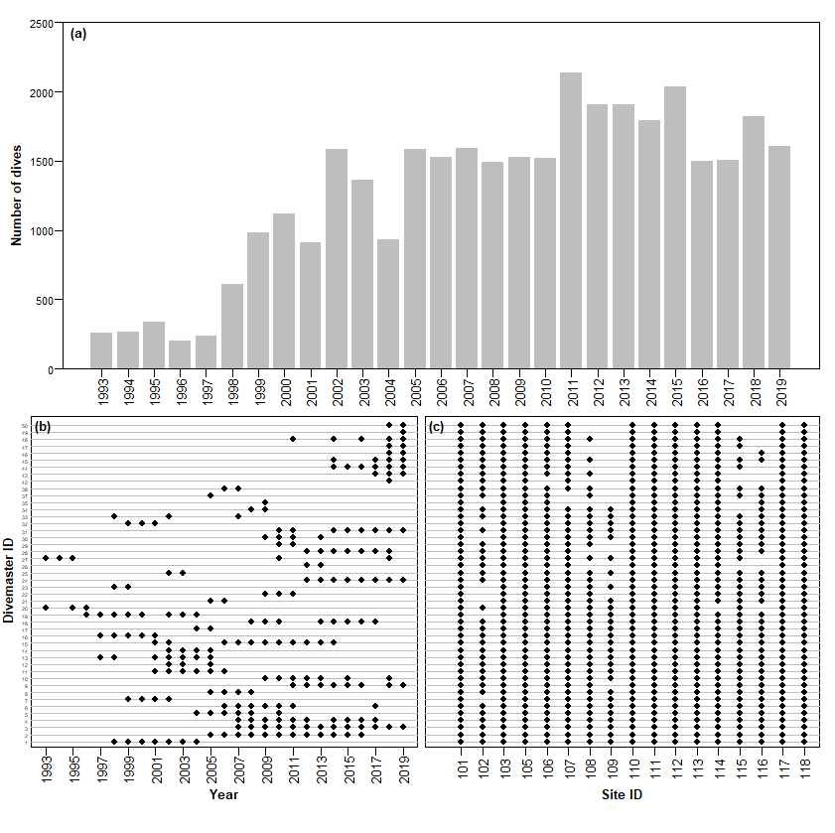
Figure S1. (a) The number of dives by year; and the dive guides that have dived each (b) year and (c) dive site at Cocos Island.
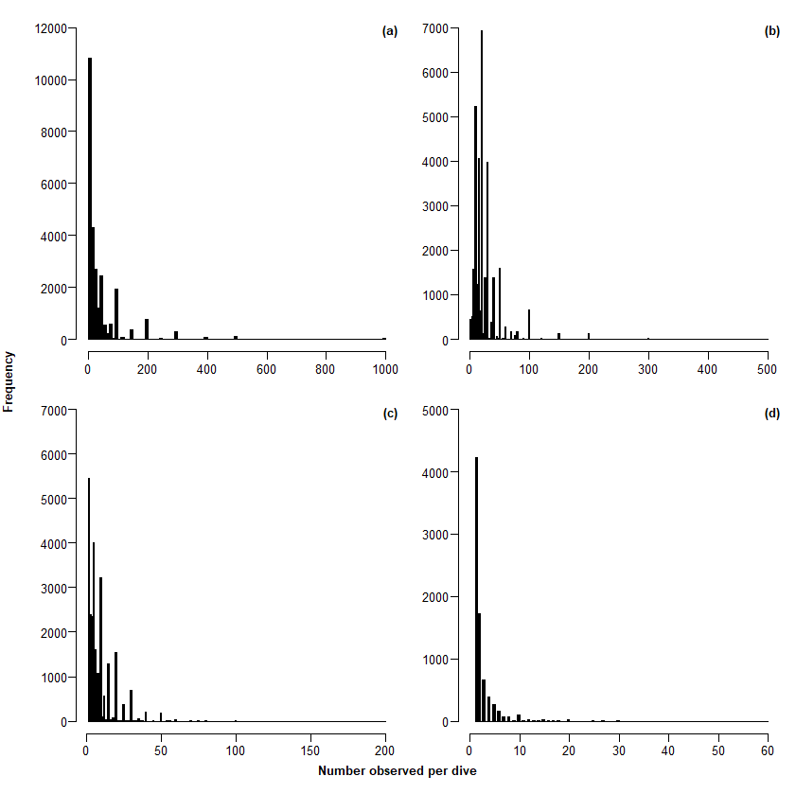
Figure S2. Histograms of counts of (a) Sphyrna lewini, (b) Triaenodon obesus, (c) Taeniurops meyeni, and (d) Aetobatus narinari observed at Cocos Island with zeros removed.

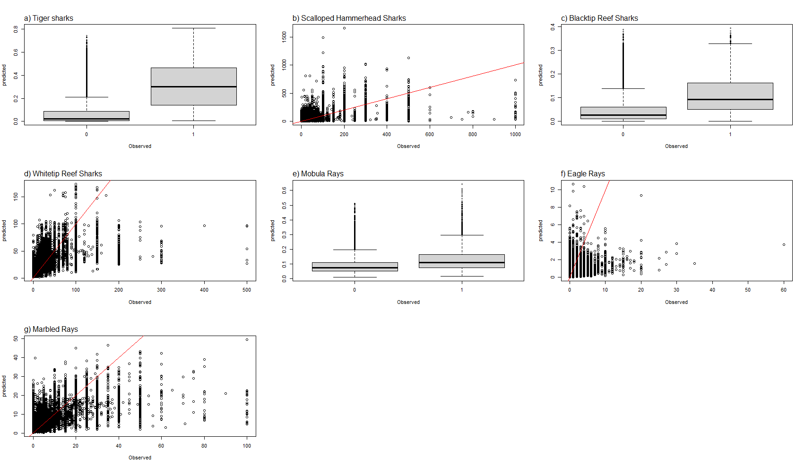

Figure S3. Predicted counts or probability of occurrence compared to observed counts or occurrence for (a) tiger sharks Galeocerdo cuvier, (b) scalloped hammerhead sharks Sphyrna lewini, (c) blacktip sharks Carcharhinus limbatus, (d) whitetip reef sharks Triaenodon obesus, (e) Mobula spp., (f) spotted eagle rays Aetobatus narinari, and (g) marbled rays Taeniurops meyeni. The red line is the 1:1 line, where appropriate. Boxplots were used when data was only presence/absence.

