**Appendix**

Appendix S1: Correlation values (Pearson’s R) amongst the variables considered.

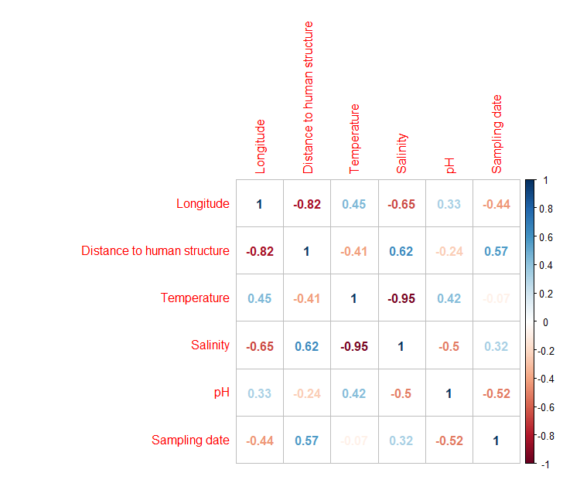

Appendix S2: Species rank abundance plots for the survey sites. Different coloured lines represent the different models used to fit the curves; the fits were done using the radfit function in the “vegan”package in R.

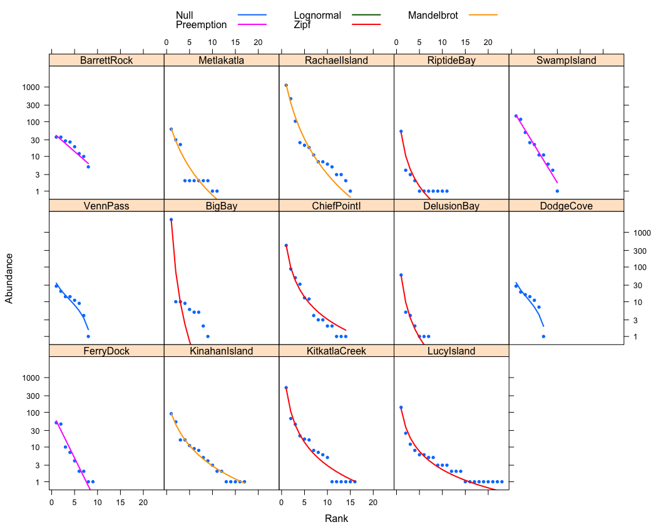

Appendix S3: All species caught and photographed along with the number of sites where species was observed (Regional occupancy, maximum of 14), the median proportion that species contributed to a site’s biomass, and the species’ morphological measurements used to calculate trait values (abbreviations as in. Fig 2). Species are ordered from highest to lowest median proportion of site biomass.



Appendix S4: Relationships between the log site-level fish community biomass and site-level abiotic variables: a) temperature b) salinity c) pH and d) eelgrass density.

